Nine-Point Circle
# Source: AI Source: Provided by: [Data Path: Persons Table -> ID Column: 1, Name_En Column: Motasem Essam] -> From: [ChatGPT] on [7/25/2026]
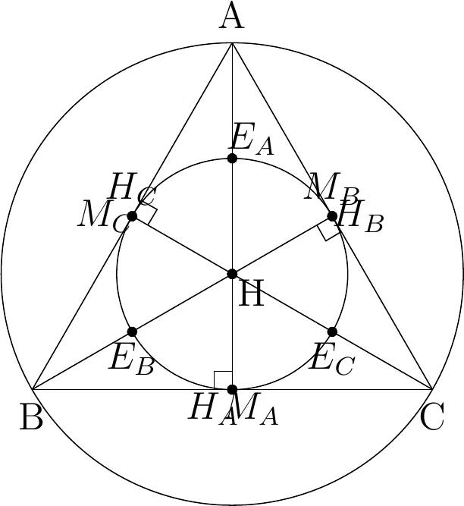
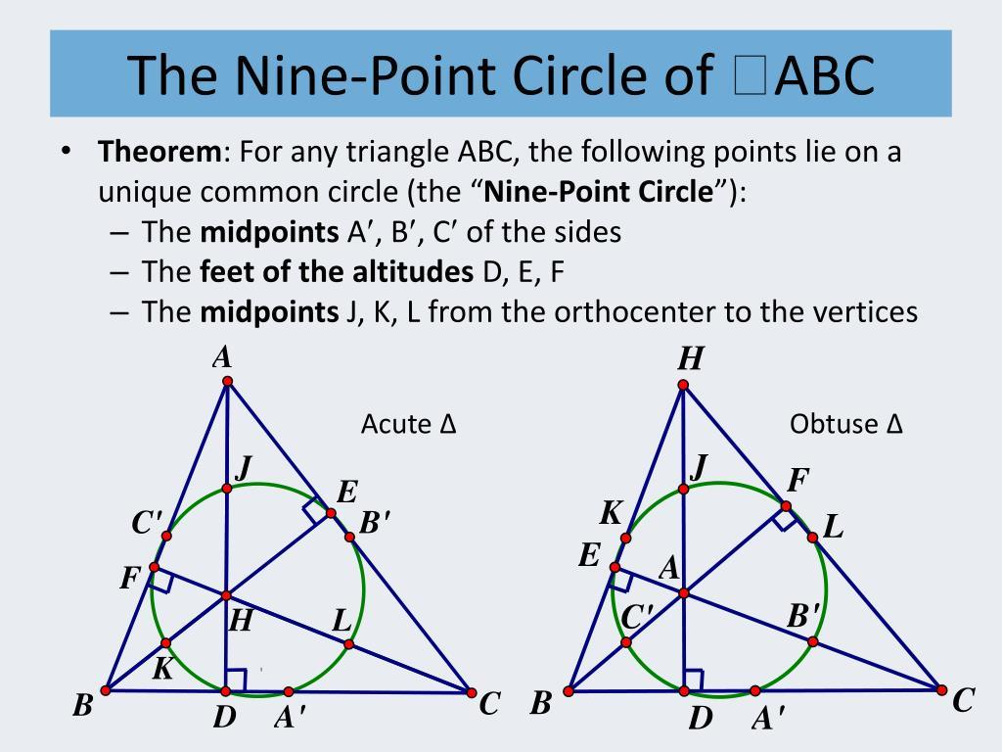
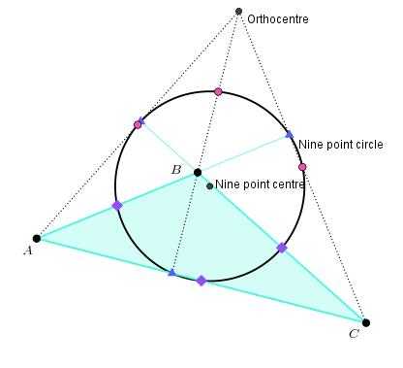
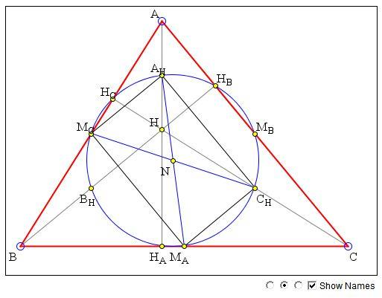

Definition
# Source: AI Source: Provided by: [Data Path: Persons Table -> ID Column: 1, Name_En Column: Motasem Essam] -> From: [ChatGPT] on [7/25/2026]
The Nine-Point Circle is a circle associated with a triangle that passes through nine important points:
- The midpoints of the three sides.
- The feet of the three altitudes.
- The midpoints of the three segments connecting each vertex to the orthocenter.
Thus, for triangle $ABC$, the Nine-Point Circle contains nine points associated with the triangle.
It is also called the Euler Circle or Feuerbach Circle in some contexts, although Nine-Point Circle is the standard name.

Purpose
# Source: AI Source: Provided by: [Data Path: Persons Table -> ID Column: 1, Name_En Column: Motasem Essam] -> From: [ChatGPT] on [7/25/2026]
The Nine-Point Circle is used to:
- Study relationships between the sides, altitudes, and orthocenter of a triangle.
- Connect the circumcenter, centroid, and orthocenter.
- Study the geometry of the Euler line.
- Provide a unified circle containing nine naturally occurring points.
- Solve problems involving triangle centers, midpoints, and perpendicularity.
- Establish important relationships between the circumcircle and the orthocenter.

The Nine Points
# Source: AI Source: Provided by: [Data Path: Persons Table -> ID Column: 1, Name_En Column: Motasem Essam] -> From: [ChatGPT] on [7/25/2026]
For triangle $ABC$, the nine points are divided into three groups.

1. Three Side Midpoints
# Source: AI Source: Provided by: [Data Path: Persons Table -> ID Column: 1, Name_En Column: Motasem Essam] -> From: [ChatGPT] on [7/25/2026]
Let:
- $D$ be the midpoint of $BC$.
- $E$ be the midpoint of $CA$.
- $F$ be the midpoint of $AB$.
Then:
$$\boxed{D,E,F\text{ lie on the Nine-Point Circle}}$$

2. Three Altitude Feet
# Source: AI Source: Provided by: [Data Path: Persons Table -> ID Column: 1, Name_En Column: Motasem Essam] -> From: [ChatGPT] on [7/25/2026]
Let:
- $P$ be the foot of the altitude from $A$.
- $Q$ be the foot of the altitude from $B$.
- $R$ be the foot of the altitude from $C$.
Then:
$$\boxed{P,Q,R\text{ lie on the Nine-Point Circle}}$$
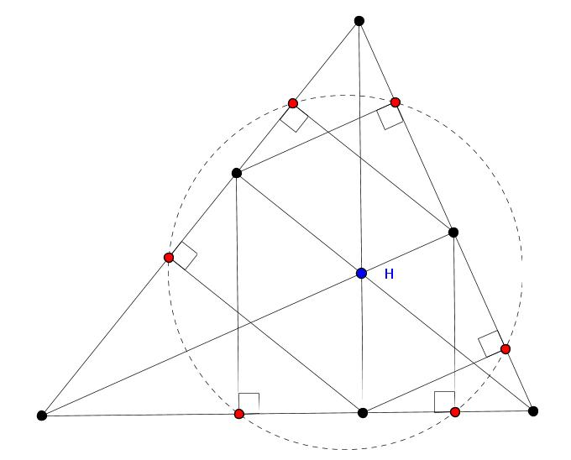
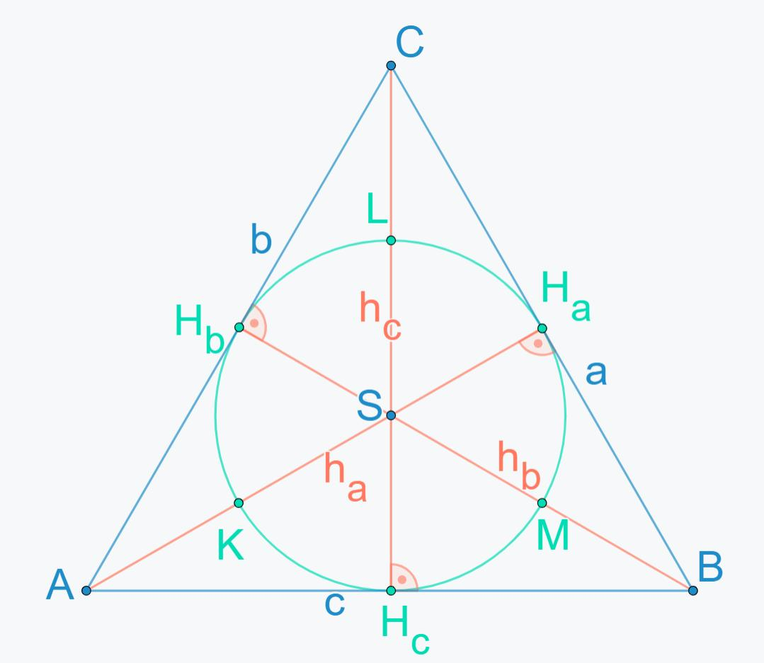
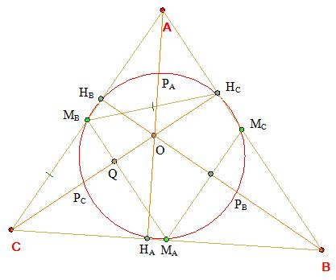

3. Three Vertex–Orthocenter Midpoints
# Source: AI Source: Provided by: [Data Path: Persons Table -> ID Column: 1, Name_En Column: Motasem Essam] -> From: [ChatGPT] on [7/25/2026]
Let $H$be the orthocenter.
Define:
- $X$as the midpoint of $AH$.
- $Y$as the midpoint of $BH$.
- $Z$as the midpoint of $CH$.
Then:
$$\boxed{X,Y,Z\text{ lie on the Nine-Point Circle}}$$
Therefore:
$$\boxed{3+3+3=9}$$
points lie on the circle.

Mathematical Representation
# Source: AI Source: Provided by: [Data Path: Persons Table -> ID Column: 1, Name_En Column: Motasem Essam] -> From: [ChatGPT] on [7/25/2026]
Let $N$be the center of the Nine-Point Circle and $R$be the circumradius of triangle $ABC$.
The radius of the Nine-Point Circle is:
$$\boxed{r_{9}=\frac{R}{2}}$$
where $R$is the circumradius of the original triangle.

Nine-Point Center
# Source: AI Source: Provided by: [Data Path: Persons Table -> ID Column: 1, Name_En Column: Motasem Essam] -> From: [ChatGPT] on [7/25/2026]
The center of the Nine-Point Circle is called the Nine-Point Center, usually denoted by $N$.
It lies on the Euler line.
If:
- $O$= circumcenter,
- $G$= centroid,
- $H$= orthocenter,
then:
$$\boxed{O,N,G,H\text{ are collinear}}$$
The Nine-Point Center is the midpoint of the circumcenter and orthocenter:
$$\boxed{N=\text{midpoint of }OH}$$
Therefore:
$$\boxed{ON=NH=\frac{1}{2}OH}$$

Relationship with the Euler Line
# Source: AI Source: Provided by: [Data Path: Persons Table -> ID Column: 1, Name_En Column: Motasem Essam] -> From: [ChatGPT] on [7/25/2026]
The Nine-Point Circle is closely connected to the Euler line.
The important centers satisfy:
$$\boxed{O-N-G-H}$$
in the common configuration.
The Euler line contains:
- Circumcenter $O$
- Nine-point center $N$
- Centroid $G$
- Orthocenter $H$
The exact visual order can vary depending on the triangle, but the collinearity relationships remain.

Why the Nine Points Are Concyclic
# Source: AI Source: Provided by: [Data Path: Persons Table -> ID Column: 1, Name_En Column: Motasem Essam] -> From: [ChatGPT] on [7/25/2026]
The key geometric reason is that the midpoint and altitude-foot points generate several right-angle configurations.
For example, consider the midpoint $D$of $BC$and the altitude foot $P$from $A$.
Because:
$$AP⊥BC$$
and $D,P$lie on $BC$, the geometry creates right triangles whose circumcircles coincide with the circle containing the other corresponding points.
Similarly, the midpoint of $AH$is connected to the altitude geometry.
These relationships ultimately show that all nine points lie on one circle.

Coordinate Representation
# Source: AI Source: Provided by: [Data Path: Persons Table -> ID Column: 1, Name_En Column: Motasem Essam] -> From: [ChatGPT] on [7/25/2026]
Suppose the triangle has vertices:
$$A=\left(x_{1} , y_{1}\right) \\ B=\left(x_{2} , y_{2}\right) \\ C=\left(x_{3} , y_{3}\right)$$
The side midpoints are:
$$\boxed{D=\left(\frac{x_{2}+x_{3}}{2} , \frac{y_{2}+y_{3}}{2}\right)} \\ \boxed{E=\left(\frac{x_{3}+x_{1}}{2} , \frac{y_{3}+y_{1}}{2}\right)} \\ \boxed{F=\left(\frac{x_{1}+x_{2}}{2} , \frac{y_{1}+y_{2}}{2}\right)}$$
If the circumcenter and orthocenter are known, the Nine-Point Center is particularly easy to obtain:
$$\boxed{N=\left(\frac{x_{O}+x_{H}}{2} , \frac{y_{O}+y_{H}}{2}\right)}$$
The Nine-Point Circle then has equation:
$$\boxed{{\left(x-x_{N}\right)}^{2}+{\left(y-y_{N}\right)}^{2}={\left(\frac{R}{2}\right)}^{2}}$$

Example
# Source: AI Source: Provided by: [Data Path: Persons Table -> ID Column: 1, Name_En Column: Motasem Essam] -> From: [ChatGPT] on [7/25/2026]
Consider a right triangle:
$$A=\left(0 , 0\right), B=\left(6 , 0\right), C=\left(0 , 8\right)$$
Its circumcenter is:
$$O=\left(3 , 4\right)$$
and its circumradius is:
$$R=5$$
The orthocenter of a right triangle is the right-angle vertex:
$$H=\left(0 , 0\right)$$
Therefore, the Nine-Point Center is:
$$N=\left(\frac{3+0}{2} , \frac{4+0}{2}\right) \\ \boxed{N=\left(\frac{3}{2} , 2\right)}$$
The Nine-Point Circle has radius:
$$r_{9}=\frac{5}{2}$$
Therefore:
$$\boxed{{\left(x-\frac{3}{2}\right)}^{2}+{\left(y-2\right)}^{2}=\frac{25}{4}}$$

Important Properties

Property 1 — Nine Points Are Concyclic
# Source: AI Source: Provided by: [Data Path: Persons Table -> ID Column: 1, Name_En Column: Motasem Essam] -> From: [ChatGPT] on [7/25/2026]
All nine special points lie on one circle:
$$\boxed{\text{Nine special points}⊂\text{one circle}}$$

Property 2 — Radius
# Source: AI Source: Provided by: [Data Path: Persons Table -> ID Column: 1, Name_En Column: Motasem Essam] -> From: [ChatGPT] on [7/25/2026]
The Nine-Point Circle has half the radius of the circumcircle:
$$\boxed{r_{9}=\frac{R}{2}}$$

Property 3 — Center
# Source: AI Source: Provided by: [Data Path: Persons Table -> ID Column: 1, Name_En Column: Motasem Essam] -> From: [ChatGPT] on [7/25/2026]
Its center $N$is the midpoint of $OH$:
$$\boxed{ON=NH}$$

Property 4 — Euler Line
# Source: AI Source: Provided by: [Data Path: Persons Table -> ID Column: 1, Name_En Column: Motasem Essam] -> From: [ChatGPT] on [7/25/2026]
The Nine-Point Center lies on the Euler line:
$$\boxed{O,N,G,H\text{ are collinear}}$$

Property 5 — Relationship with the Centroid
# Source: AI Source: Provided by: [Data Path: Persons Table -> ID Column: 1, Name_En Column: Motasem Essam] -> From: [ChatGPT] on [7/25/2026]
Since $G$divides $OH$in the ratio $1:2$, while $N$is the midpoint of $OH$:
$$\boxed{GN=\frac{1}{6}OH}$$

Feuerbach Point
# Source: AI Source: Provided by: [Data Path: Persons Table -> ID Column: 1, Name_En Column: Motasem Essam] -> From: [ChatGPT] on [7/25/2026]
The Nine-Point Circle has an important relationship with the incircle and the three excircles.
This is expressed by Feuerbach's theorem:
The Nine-Point Circle is internally tangent to the incircle and externally tangent to the three excircles.
The point of tangency with the incircle is called the Feuerbach point.
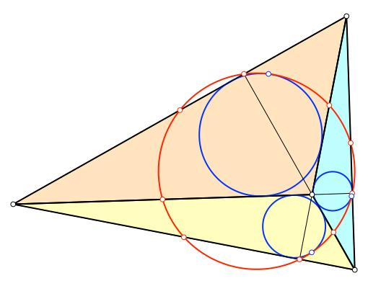
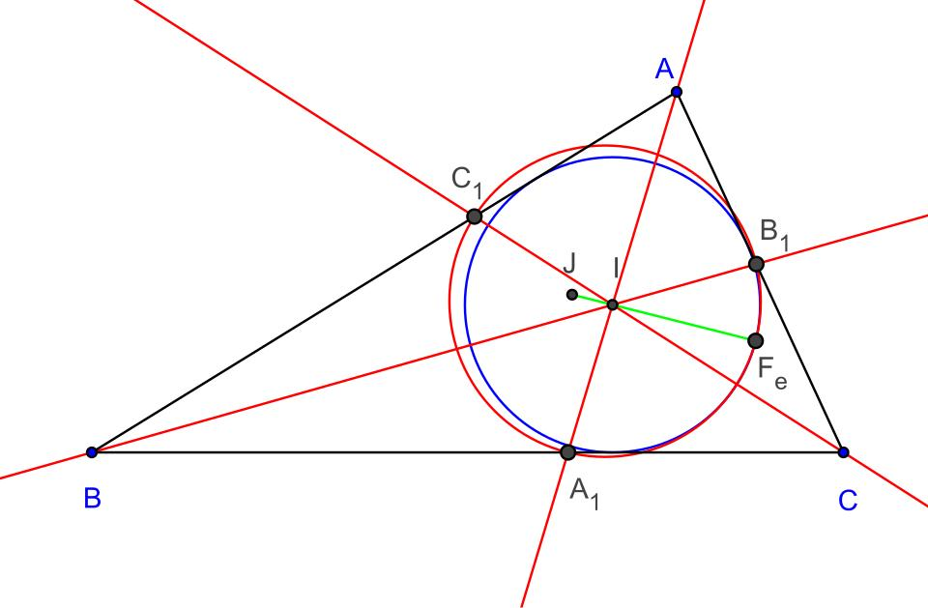
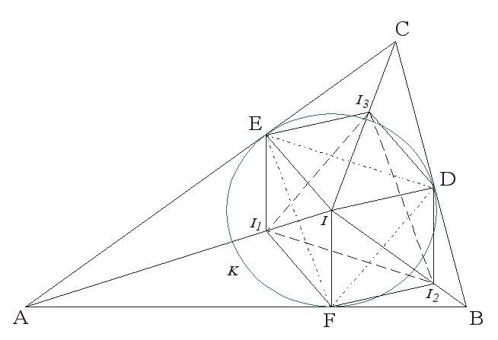
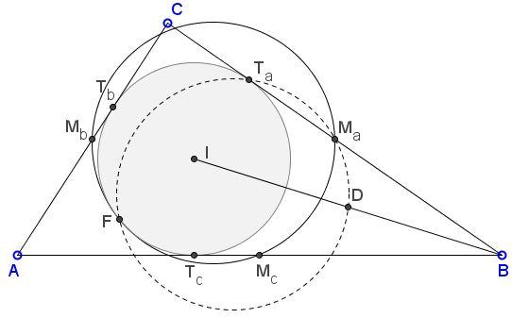
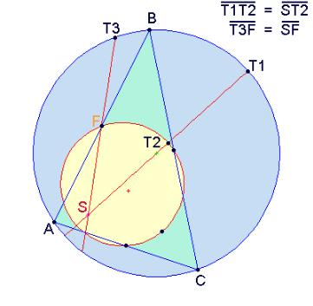

Special Case: Right Triangle
# Source: AI Source: Provided by: [Data Path: Persons Table -> ID Column: 1, Name_En Column: Motasem Essam] -> From: [ChatGPT] on [7/25/2026]
For a right triangle, the Nine-Point Circle has a particularly simple relationship with the hypotenuse.
The midpoint of the hypotenuse is the circumcenter $O$.
The right-angle vertex is the orthocenter $H$.
Therefore, the Nine-Point Center $N$is the midpoint of the segment joining:
$$O \text{and} H$$

Special Case: Equilateral Triangle
# Source: AI Source: Provided by: [Data Path: Persons Table -> ID Column: 1, Name_En Column: Motasem Essam] -> From: [ChatGPT] on [7/25/2026]
For an equilateral triangle:
$$\boxed{O=G=H=I}$$
All three side midpoints, altitude feet, and vertex–orthocenter midpoints coincide in groups of three.
The Nine-Point Circle therefore still exists, but its nine defining points reduce to three distinct points because of the symmetry of the equilateral triangle.
Its radius is still:
$$\boxed{r_{9}=\frac{R}{2}}$$

Comparison with the Circumcircle
# Source: AI Source: Provided by: [Data Path: Persons Table -> ID Column: 1, Name_En Column: Motasem Essam] -> From: [ChatGPT] on [7/25/2026]
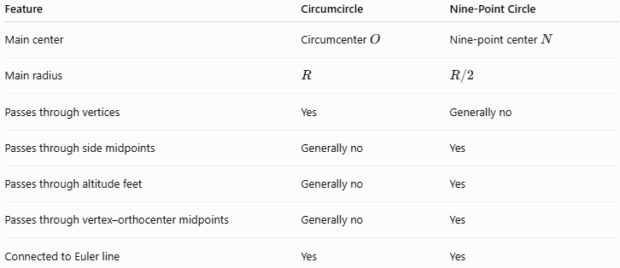
Feature | Circumcircle | Nine-Point Circle
Main center | Circumcenter $O$ | Nine-point center $N$
Main radius | $$R$$ | $$R/2$$
Passes through vertices | Yes | Generally no
Passes through side midpoints | Generally no | Yes
Passes through altitude feet | Generally no | Yes
Passes through vertex–orthocenter midpoints | Generally no | Yes
Connected to Euler line | Yes | Yes

Relationship with Triangle Centers
# Source: AI Source: Provided by: [Data Path: Persons Table -> ID Column: 1, Name_En Column: Motasem Essam] -> From: [ChatGPT] on [7/25/2026]
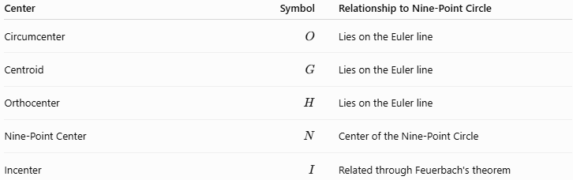
Center | Symbol | Relationship to Nine-Point Circle
Circumcenter | $$O$$ | Lies on the Euler line
Centroid | $$G$$ | Lies on the Euler line
Orthocenter | $$H$$ | Lies on the Euler line
Nine-Point Center | $$N$$ | Center of the Nine-Point Circle
Incenter | $$I$$ | Related through Feuerbach's theorem

Key Points
# Source: AI Source: Provided by: [Data Path: Persons Table -> ID Column: 1, Name_En Column: Motasem Essam] -> From: [ChatGPT] on [7/25/2026]
- The Nine-Point Circle is associated with nine special points of a triangle.
- Three are side midpoints.
- Three are altitude feet.
- Three are midpoints of the vertex–orthocenter segments.
- Its center is the Nine-Point Center $N$.
- Its radius is:
$$\boxed{\frac{R}{2}}$$
- $N$is the midpoint of $OH$.
- $N$lies on the Euler line.
- Feuerbach's theorem connects it with the incircle and excircles.

Conclusion
# Source: AI Source: Provided by: [Data Path: Persons Table -> ID Column: 1, Name_En Column: Motasem Essam] -> From: [ChatGPT] on [7/25/2026]
The Nine-Point Circle is one of the most important circles in triangle geometry because it unifies side midpoints, altitude feet, and orthocenter-related midpoints into a single circle. Its center lies naturally on the Euler line, and its radius is exactly half the circumradius, creating a strong connection between the circumcircle, Euler line, orthocenter, and triangle centers.

